Testplan

# Unit Testing

Writing TestCases or a Test Plan for Unit Testing seems to like it will always be made after the fact than moreso before, but I guess that’s what makes it agile. UnitTests are meant to test functions inside of your code. If I had to write Unit Test Cases for every single method inside of my project it will be 1000 kilometers long, but since unittesting is only really effective on the service layer means that there are a lot less testcases to write.

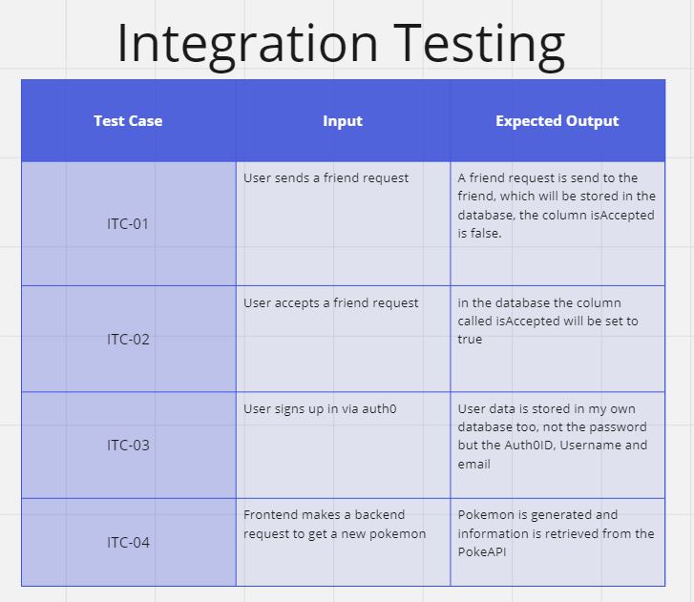

# Integration Testing

Integration tests are meant for testing the integration of your system with an external one, like a database. So my integrationtests do exactly that. Test the integration with the external database.

I think writing TestCases for integrationtests are more useful than for unit tests, because you know that you will be connecting to an external database and what you are going to store and not.

# End to End Testing

E2E (End to end) tests are really tests that apply on your frontend. They test if an action you do has the desired output. One of my tests tests if the user presses the login button, that they should be redirected to Auth0. Another is that if a user is logged in they should be able to see their username both in the middle of the screen and in the top right. The login button should also be changed to a logout button.

Another one of my test is practicing guessing pokemon. Changing the time and the generation and that those features actually work.

Then ofcourse the friendslist, you want to be able to open the chat and see that it works, that a chat message is sent, and when you say nothing, that nothing will be sent when you press send.